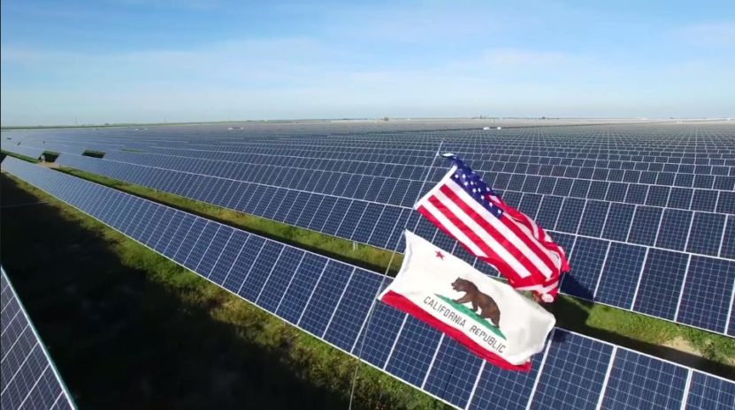

**Solar Energy in California**

Los Angeles 03.02.2019

University of Southern California

Data Analytics Certified Program

Adriana Rubalcaba, Dylan Kaiser, Anna Miller

**Table of content:**

Hypothesis 3

Abstract 4

Interesting facts 5

Data analysis 6

Summary

**Hypothesis**

If the climate zone is different, then the number of installations stays the same.

If the temperature in particular climate zone is higher the size of solar energy installation is bigger.

If the climate zone is colder then there are less installations during winter.

If the climate zone is warmer the cost of solar energy installation decrease.



**Abstract**